List of hotels for PAGE2008
Numbers on the map refer to hotel descriptions below
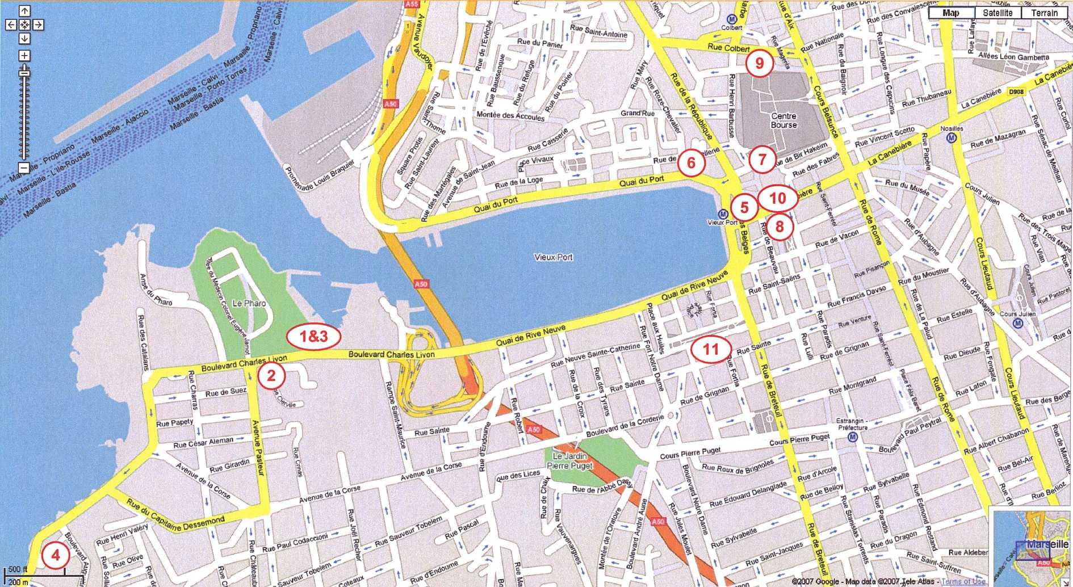

Name | Cat | Metro/bus | Transportation time | Price in euros
Hotels around Pharo |  |  |  | Single | Double/Twin
1. Sofitel vieux Port | **** | M. Vieux Port | 15 mn ( + 15 mn walk) | 229/274 | 262/307
2. New Hôtel Pharo | *** | M. Vieux Port | 15 mn ( + 15 mn walk) | 214 | 252
3. Novotel Vieux Port | *** | M. Vieux Port | 15 mn ( + 15 mn walk) | 158 | 180
4. Péron | ** | Bus 83+M Castellane | 35 mn | 86 | -
Hotels around the city centre / Vieux Port
5. Tonic Hôtel VP | *** | M. Vieux Port | 15 mn | 145/180 | 180/215
6. Résidence du Vieux Port | *** | M. Vieux Port | 15 mn | 109 | 139
7. New Hôtel Vieux Port | *** | M. Vieux Port | 15 mn | 174 | 207
8. Mercure Beauvau | *** | M. Vieux Port | 15 mn | 211 | 240
9. Mercure Eurocentre | ** | M. Colbert | 15 mn | 133 | 157
10. Hôtel Mascotte | ** | M. Vieux Port | 15 mn | 108 | 118
11. Etap Hôtel Vieux Port | ** | M. Vieux Port | 15 mn | 49 | 58

Hotels around the Pharo
1.Hôtel Sofitel Vieux Port ****
36, Boulevard Charles Livon
13007 Marseille
www.sofitel.com
Situated in the heart of Marseille on the rockly promontory of the Palais du Pharo and its gardens, the Sofitel overlooks the Vieux Port and offers one of the most beautiful panoramic views of the city sweeping all the way round from the Estaque and to Notre Dame de la Garde.
The hotel offers you a gourmet restaurant “Les Trois Forts” with 180° panoramic view of Marseille. The hotel is blessed with direct access by motorway from Lyon, Montpellier or Nice directions. It is also 20 minutes from Marseille Provence Airport, 15 minutes from the Saint-Charles railway station and 15 minutes on foot from the city centre.
2.New Hôtel of Marseille ****
71 boulevard Charles Livon.
13007 Marseille
www.newhotelofmarseille.com
The hotel has an exceptional location: opposite the Pharo Congress Centre, close to the Vieux Port and five minutes walk from the city centre. The hotel is easily accessible by car and public transport.
The New Hotel Of Marseille – Le Pharo is a top quality hotel for any kind of stay, from leisure breaks to tailor-made events and seminars.
This modern designer hotel, decorated in a refined style embellished with splashes of colour, offers 100 rooms, the “Le Victor Café” restaurant with a terrace in summer, a bar, swimming pool with solarium, meeting rooms, a business centre, a public car park is under basement with 40 places reserved to the hotel guests (chargeable: 9 €/24 h to be paid at reception), pay WIFI (chargeable: 17 €/24 h in room, 20 €/hour in the business centre).
On the first three floors, the hotel has 81 standard rooms with double or twin beds (two single beds) and three disabled rooms. The top “Executive Floor” has eight superior rooms and eight suites, all with individual terrace. Non-smoking rooms are also available.
3.Hôtel Novotel Vieux Port ***
36, boulevard Charles Livon
13007 MARSEILLE
www.novotel.com
Located in the heart of the city overlooking the Vieux Port. Near the beaches in a green environment. 90 rooms. Restaurant with a panoramic terrace with stunning views. Seminar rooms, swimming pool, bar, parking.
4.Hôtel Péron
119, corniche Kennedy
13007 Marseille
www.hotel-peron.com
Created in 1925, this little palace was transformed into a family hotel and has been run by the same family for four generations. In the 1960s, during his stay a painter redecorated the rooms, giving an original atmosphere to each on of them (some regional, some romantic, and some exotic). The hotel is located in Marseille with sea views and views of the Chateau d'If.

Hotels around the Vieux Port
5.Tonic Hôtel ***
43, Quai des Belges
13001 MARSEILLE
www.hotels-de-marseille.com
In the heart of Marseille, on the quays of Vieux Port, the Tonic Hotel has an easy access with the Saint Charles railway station at 10 minutes, the Marseille Provence Airport at 20 minutes and at 5 minutes on foot from the World Trade centre and the Pharo Palace. 60 air-conditioned and soundproofed bedrooms welcome you for a soothing peaceful stay; each of them offers an adjoining bathroom and all amenities.
6.La Résidence du Vieux Port ***
18, Quai du Port
13002 Marseille
www.hotelmarseille.com
Standing on the Old Port of Marseille, La Résidence du Vieux Port is the most favourite hotel of guests with a sensitive eye to beauty: all 40 rooms offer you a panoramic view of Notre Dame de la Garde-Basilica perches above, St Victor-Abbey, the Ferry-Boat and the Palais du Pharo. Full of charm and entirely renewed, all rooms are very comfortable.
7.New Hôtel Vieux Port ***
3 bis, Rue Reine Elisabeth
13001 MARSEILLE
www.new-hotel.com
In the free-shop renovated and refitted rooms of the New Hotel Vieux Port, you will be transported to faraway places with names evocative of images and perfumes: « Land of the Rising Sun, Arabian Nights, African Adventures, Pondichery, and Vera Cruz ». Fine fabriques and furniture and superb bathrooms have been chosen for comfort – these are good reasons for you to enjoy your stay a stone’s throw from the famous boulevard la Canebière, just by the Vieux Port Here no artificial touristy effects are needed – you just have to walk around to experience the everlasting charm of Marseille. Travellers, welcome!
8.Hôtel Mercure Beauvau ***
4, rue Beauvau
13001 MARSEILLE
www.mercure.com
Located in the centre of Marseille opposite to the Vieux Port. The oldest hotel in town. Many famous writers stayed here. Ancient Provencal-style furniture in 72 air-conditioned and soundproofed rooms. Paying covered car park. Bar.
9.Hôtel Mercure Euro centre ***
1, rue Neuve St Martin
13001 Marseille
www.mercure.com
Provencal brasserie, bar, meeting/banquets facilities (1500 m2) fully renovated and equisetum, business centre.
Hotel Facilities: Baby Sitting, Car Rental / Car Hire, Disabled Facilities, Laundry Cleaning Service, Parking - Coach/Bus, Parking / Car Park, Room Service – Limited, Wakeup Service Room Facilities : Air Conditioning, Hairdryer, In-room Movies, Mini-bar, Non Smoking Guestrooms, Radio, Telephone / Direct Dial, Television, Voltage 220/240.
10.Hôtel Mascotte ***
5, La Canebière
13001 Marseille
www.oceaniahotels.com
Situated on the famous « Canebière » facing The Vieux Port in heart of the tourist, cultural and commercial quarters, the hotel MASCOTTE invites you to discover the joys of Marseille life with Mediterranean temperatures.
11.Etap Hôtel Vieux Port **
46 Rue Sainte
13001 Marseille
www.etaphotel.com
Situated in the heart of the city, the Etap hotel offers spacious and modern room, with a shower, toilet, and satellite TV.

